Handout no. 09

|  |  |
| --- | --- |
| **Name** | M Umar Saleem, M Usama, Abdul Jabbar |
| **Reg. No** | 2019-EE-356,366,376 |
| **Marks/Grade** |  |

**EXPERIMENT # 09**

**Parameter setting of Directional Earth/Overcurrent Fault Relay for Transmission Line Protection.**

**Objective:**

At the end of this lab session students will be able to

* Use De Lorenzo power system Protection kits.
* Implement of Directional Earth Fault Relayby using De Lorenzo power system Protection kits.
* Relay behaviour in three phase systems for Overcurrent conditions.
* Determination of resetting ratio

**Introduction:**

A relay is usually an electromechanical device that is actuated by an electrical current. The current flowing in one circuit causes the opening or closing of another circuit. Relays are like remote control switches and are used in many applications because of their relative simplicity, long life, and proven high reliability. Relays are used in a wide variety of applications throughout industry, such as in telephone exchanges, digital computers and automation systems. Highly sophisticated relays are utilized to protect electric power systems against trouble and power blackouts as well as to regulate and control the generation and distribution of power. In the home, relays are used in refrigerators, washing machines and dishwashers, and heating and air-conditioning controls.

Although relays are generally associated with electrical circuitry, there are many other types, such as pneumatic and hydraulic. Input may be electrical and output directly mechanical. All relays contain a sensing unit, the electric coil, which is powered by AC or DC current. When the applied current or voltage exceeds a threshold value, the coil activates the armature, which operates either to close the open contacts or to open the closed contacts. When a power is supplied to the coil, it generates a magnetic force that actuates the switch mechanism

**Apparatus:**

* 1DL 1013T1 Experimentation Transformer
* 1DL 1017R Resistive load
* 1 DL 1080TT Three phase transformer
* 1 DL 2108TAL-SW Three Phase power Supply unit
* 1 DL 2108T02 Power Circuit Breaker
* 1 DL 2108T16 Earth Fault warning relay
* 1 DL 2109 T2A5 Moving Iron Ammeter (2.5)
* 1 DL BUZ Acoustic continuity tester

**Directional Relay:**

The over-current protection can be given directional feature by adding directional element in the protection system. Directional over-current protection responds to over-currents for a particular direction flow. If power flow is in the opposite direction, the directional over-current protection remains un-operative. Directional overcurrent relays respond to excessive current flow in a particular direction in the power system. The relay typically consists of two elements. One is a directional element, which determines the direction of current flow with respect to a voltage reference. When this current flow is in the predetermined trip direction, this directional element enables ("turns on") the other element, which is a standard overcurrent relay, complete with taps and time dial, as found on a normal non-directional overcurrent relay. Because these relays are designed to operate on fault currents, the directional unit is made so that it operates best on a highly lagging current, which is typical of faults in power systems

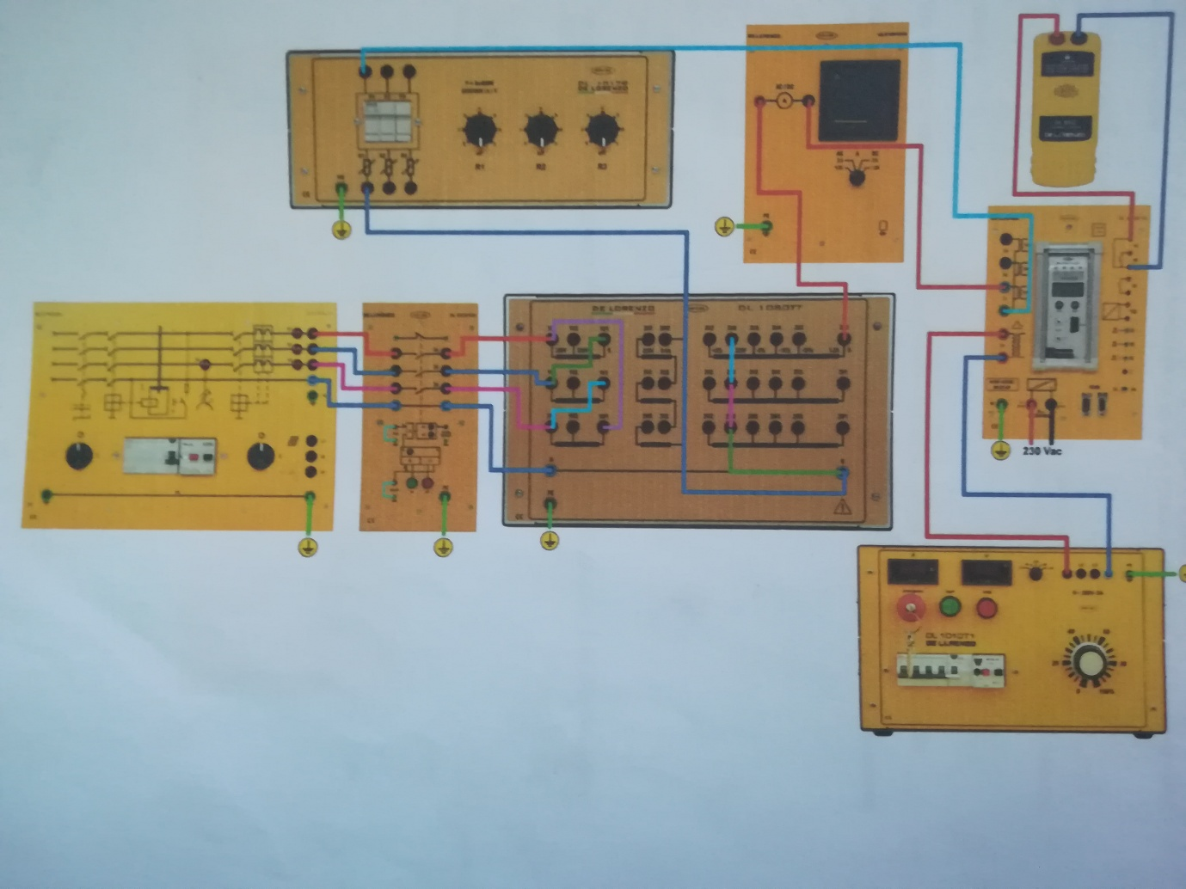

Figure 1: Experimental Setup of Earth Overcurrent Relay

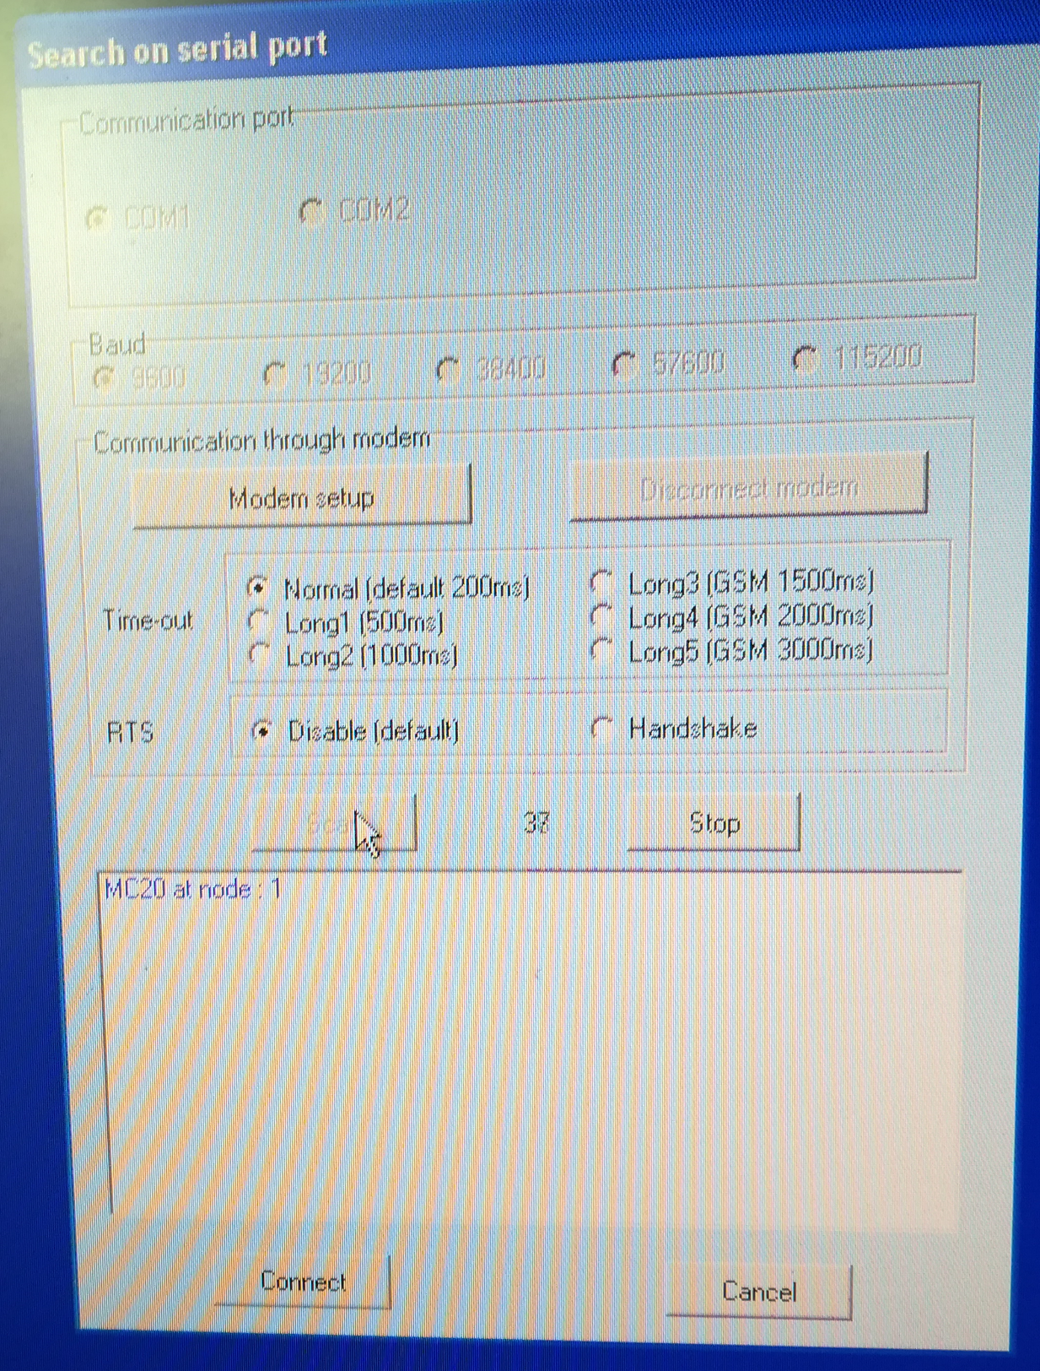

Figure 2: Create communication link of Relay

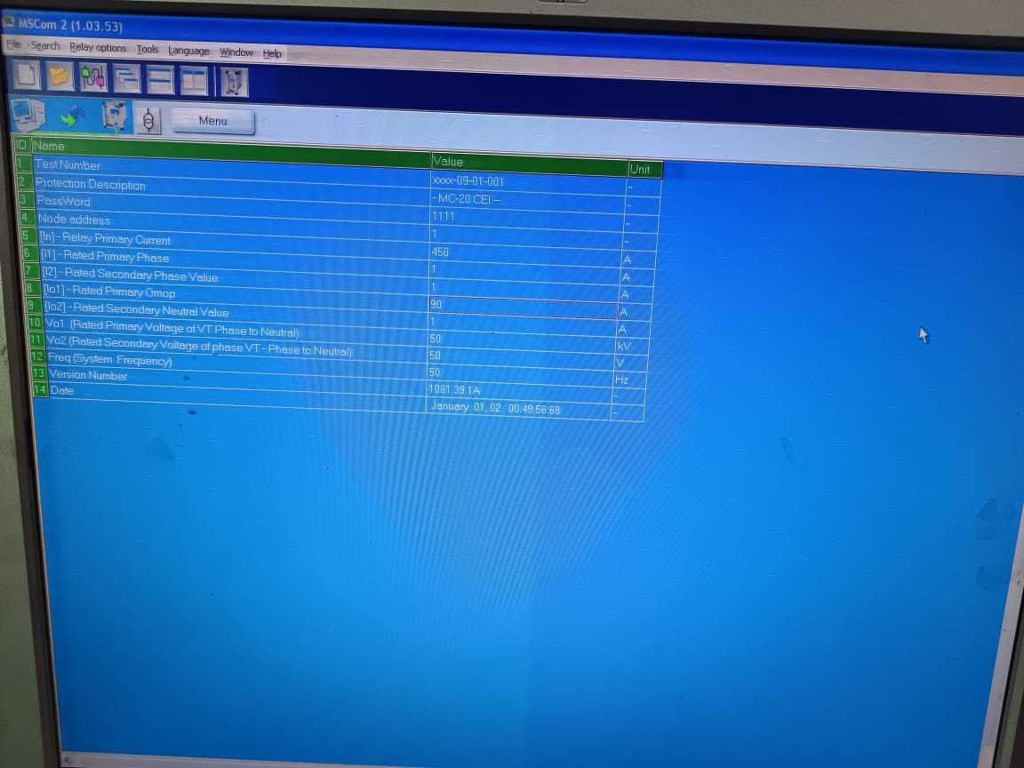

Figure 3: Setting of Fault current Value under fault condition

**Procedure:**

* Connect circuit as shown in Fig 1
* Create communication link of Relay
* Set the fault current value.
* Set three phase power supply voltage 380v and relay is not in operation.
* Positioning the load R1 to 1 on the equipment DL 1017R.
* Switch on the power interrupt DL 2108T02.
* Observe the increment of current Io. The increment of current identifies a typical leakage event to earth in one device separated from ground.
* Change the resistance from R2 to R3 position and observe a new increment of current after the trip LED.

|  |  |  |  |
| --- | --- | --- | --- |
| **Set value of Io** | **Trip value of I01=** | **Measured Value** | **Error** |
| **120** | **66.7** | **66.5** | **0.29** |
| **140** | **77.7** | **77.5** | **0.25** |
| **160** | **88.8** | **88.6** | **0.22** |
| **180** | **100** | **99.9** | **0.1** |

**Observation:**